Carbon Reduction Plan for PPN 06/21 Company: ActionAid
30 Sept 2021

Date:

Commitment to achieving Net Zero
ActionAid is committed to achieving Net Zero by 2040 and is taking steps to try and further reduce this timeline where possible.

Baseline Emissions
Baseline emissions were recorded for year ending December 2020 and were produced by Positive Planet in accordance with GHG Protocols for scopes 1,2 & 3 as follows;

Scope 1 0.56 tCO2e
Scope 2 10.54 tCO2e (includes -50.17 tCO2e REGO)
Scope 3 303.57 tCO2e

Total Emissions 314.67 tCO2e

The baseline measurement was taken in 2020, which was a Covid-19 affected year. The effects of Covid-19 on the business largely impacted travel to and from the office (employee commuting) and around the world, to visit the projects ActionAid are engaged in (organisational travel and accommodation).

Further data analysis suggests that 2019 would have had emissions of c.800 tCO2e, with approximately 400 tCO2e of that coming from organisational travel alone.

Emission Reduction Targets
There are no existing carbon emission reduction targets on which to report any progress at this time.

In order for ActionAid to progress towards Net Zero, new carbon reduction targets have been set for the future. Carbon reduction plans to 2025 include the following actions;

Reduction Plan |  | Subtotal  231.81 tCO2e
Description | Target Date | tCO2e Reduction
Reduce non-recyclable waste across all AAUK offices by 80% | 2025 | 0.31 tCO2e
Move to 100% renewable electricity in both AAUK offices | 2025 | 60.71 tCO2e
Use Carbon Neutral couriers for all deliveries | 2024 | 170.79 tCO2e
Reduce business air travel by 60% over 2019 (will be higher than 2020 base year due to Covid-19 restrictions) | 2022 | n/a
Promote rail as primary choice for all short-haul business travel incl. UK and mainland Europe | 2022 | n/a

It is projected that by achieving the above targets, carbon emissions will be 600 tCO2e in 2025 putting ActionAid on track to achieve Net Zero by 2040.

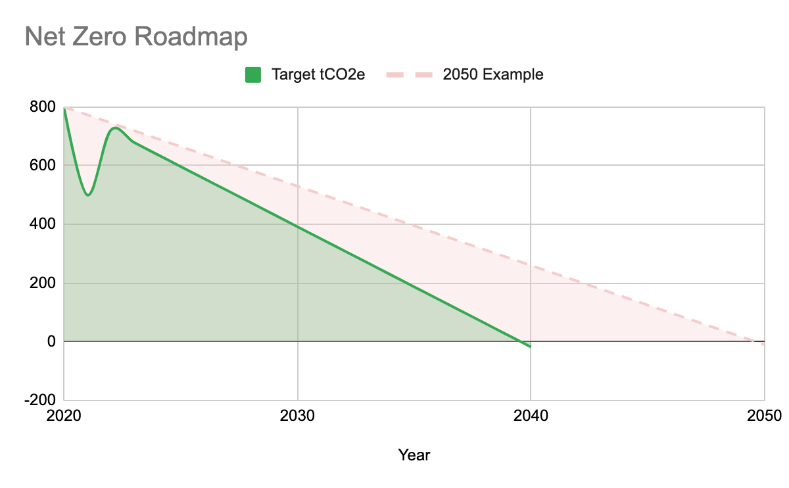

In the future ActionAid hope to engage with environmental projects and other voluntary schemes, such as;

- ISO 14001 Certification
- Positive Planet – Employee Engagement
- The Climate and Environment Charter for humanitarian organisations

Declaration
This Carbon Reduction Plan has been completed, with the help of Positive Planet, in accordance with PPN 06/21 and associated guidance and reporting standards for Carbon Reduction Plans.

Emissions have been reported and recorded in accordance with the published reporting standard for Carbon Reduction Plans and the GHG Reporting Protocol corporate standard and uses the appropriate Government emission conversion factors for greenhouse gas company reporting.

Scope 1 and 2 emissions have been reported in accordance with SECR requirements, and the required subset of Scope 3 emissions have been reported in accordance with the published reporting standard for Carbon Reduction Plans and the Corporate Value Chain (Scope 3) Standard.

This Carbon Reduction Plan has been reviewed and signed off by the board of directors (or equivalent management body).

Signed on behalf of ActionAid

Name: John Good (COO)

Signed: John Good

Date: 30/09/2021

